ProjectDesignPhase-II DataFlowDiagramUserStories

|  |  |
| --- | --- |
| Date | 03 October2022 |
| Team ID | PNT2022TMID39010 |
| Project Name | Signs with Smart Connectivity for Better Road Safety |
| Maximum Marks | 4Marks |

**Data Flow Diagram:**

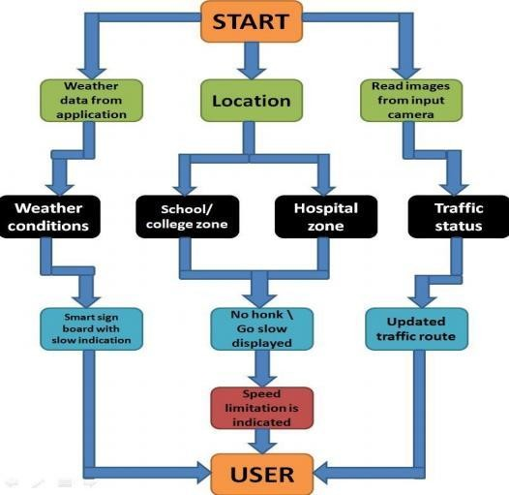

**UserStories**

|  |  |  |  |  |  |  |
| --- | --- | --- | --- | --- | --- | --- |
| **UserType** | **Functional Requirement**  **(Epic)** | **UserS toryN umbe r** | **UserStory/Task** | **Acceptance criteria** | **Priority** | **Release** |
| Customer | Registration | USN-1 | I can get my speed | I can receive | High | Sprint-1 |
| (Mobileuser) |  |  | limitation | speed |  |  |
|  |  |  | using weather | limitations |  |  |
|  |  |  | application. |  |  |  |
|  |  | USN-2 | As a user,I can register for the application by entering my email,passwor d,and confirming my password. | I can access My account  /dashboard | Medium | Sprint-2 |
|  |  | USN-3 | As a user,I can | I can | High | Sprint-1 |
|  | increase or  decrease my | Increase or decrease my |  |  |
|  | speed | speed |  |  |
|  | according to |  |  |  |
|  | the weather |  |  |  |
|  | change |  |  |  |
|  |  | USN-4 | As a user,I can get my traffic diversion | I can access my traffic status ahead in my | Medium | Sprint-1 |
|  | signs depending | travel |  |  |
|  | on the traffic and |  |  |  |
|  | the fatal |  |  |  |
|  | situations. |  |  |  |
|  | Login | USN-5 | As a user,I can log | I can access the | High | Sprint-2 |
|  |  | Into the open | application through my |  |  |
|  |  | Weather map by | gmail login |  |  |
|  |  | Entering email & |  |  |  |
|  |  | password |  |  |  |
|  | Interface | USN-6 | As a user the interface should be simple and easily  accessible | I can access the Interface easil y | High | Sprint-1 |

|  |  |  |  |  |  |  |
| --- | --- | --- | --- | --- | --- | --- |
| Customer (Web user) | Data generation | USN-7 | As a user I use open weather application to access the data regarding the weather changes. | I can access the data regarding  the weather through the application. | High | Sprint-1 |
| Administrator (Officials) | Problem solving/ Fault clearance | USN-8 | As an official who is incharge for the proper functioning of the signboards have to maintain it through periodic monitoring. | Officials can  monitor the  signboards for proper functioning. | Medium | Sprint-2 |